PVEOut Operative Meeting

Florence

2nd Part

8 November 2002
Participants:
- Ali Hojjat
- Bruno Alfano
- Claus Svarer
- Karim Berkouk
- Mario Quarantelli
- Miclos Emri
- Olaf Paulson
- Tim Dyrby
From 14:45 Lapo Bertini and Auro Pampaloni (Rasna) joined the meeting until 16:30.

As the meeting room originally scheduled at Rasna Headquarter was not available, as declared in the e-mail from Lapo Bertini, CEO of Rasna Imaging Systems, to the coordinator dated 4-11-2002, received by Dr. Alfano only on the 6th of November at 13:20 (attachment I), when calling Rasna to verify that the meeting would take place as originally planned, availability of the breakfast room as a meeting room at the Hotels were partners were staying was verified.
The participating partners were then reached at their hotels Thursday night by the coordinator and by Dr. Quarantelli, and it was decided that the meeting would have been held at the Hotel Embassy in Florence, 8/11/2002 starting at 10:30.
The availability of the room, upon confirmation by the Hotel, was communicated on phone to Rasna Friday morning, who replied that they would join the meeting later on, subsequently confirming their participation for one hour in the afternoon.
Accordingly, the meeting agenda was defined in agreement between all partners including the following issues

Update on Mid-Term Review outcome

Rasna position inside the project

Exploitation strategy alternative to the one proposed by Rasna

New work-plan for main program

Tools to be used to generate the main program

Protocols for data exchange between modules

Definition of Workflow

File format conversion (DICOM/Analyze/Others?).

The coordinator announced that he had just received the Evaluation provided by the External Reviewer from the Mid-term Review, which he read to the partners and that will be forwarded to the general mailing list immediately.

Among the others, the reviewer had emphasized the importance, to maximize the success of the project, of a reliable exploitation plan, and to merge the WP2 and WP5, to have external clinical research centers test the software and give a feed-back to improve it, also maximizing the diffusion of the product.

All the participants underscored that this was obstructed by Rasna’s need to have the partner develop the product on their platform and using their software (implying payment to Rasna for their licenses, even if at favorable price).
On the other hand, no activity by Rasna had been carried out in this direction, which left the consortium without a suitable unique software package for internal use, and even more important, for external distribution at selected centers.
As a consequence, the attending partners agreed that the coordinator should re-consider Rasna position inside the project, and discuss it with the other responsible persons.

The coordinator agreed that there was a need for an Exploitation strategy alternative to the one proposed by Rasna, who was not providing the software needed to complete the PVEOut package.

This was furthermore needed to follow reviewer suggestions, reasonable and well targeted in view of the research experience of participating scientific partners.
After completing the software package with tools to be defined (see below) possibility of distribution to selected centers of the software should be considered according to reviewer suggestions.
Claus Svarer and Mario Quarantelli pointed out the example of SPM, a package running in Matlab which had been distributed as freeware for several years, accumulating a huge number of users, and was now also sold as C-compiled version within a software package called Med-X, which is acquired by scientists who are not willing or cannot do the installation of the software personally, and prefer to pay a software house to do it for them.
The presence of SPM module is considered by Dr. Quarantelli the main reasons for Med-X commercial success.
Mario Quarantelli and Claus Svarer asked this hypothesis to be considered as possible exploitation by the consortium.
As a starting point to test this hypothesis, availability of the partners in charge of each module to have it diffused was requested by the coordinator.
It was reminded that, for all the modules except the co-registration, distribution only of the executable was possible as consequence of the correct choices in the initial part of the project, which would preclude the loss of intellectual property rights by the partners.
The following positions, to be confirmed by direct declarations by the other responsible persons, emerged

Module | Center in Charge | Availability
Co-Registration (MARS) | RHC-NRU - Copenhagen | Freeware
Segmentation - monoparametric | UKENT - Canterbury | Restricted to the consortium
Segmentation – multiparametric | CNR - Naples | Freeware for selected centers upon request
Digital Atlas | CNR - Naples | Freeware for selected centers upon request
PVE - correction | CNR - Naples | Freeware for selected centers upon request
PET Simulator | UDEB_PETC Debrecen | Freeware

It was also verified that all the components of external software included in the co-registration module (AIR by Roger Woods and SPM by the Wellcome Cognitive Department of London) were freeware, so their download and inclusion in the package could be easily guided to have external centers obtain the full PVEOut set-up.
Regarding the monoparametric segmentation, Dr. Quarantelli asked Dr. Hojjat, in view of the suggestions by the reviewer, to verify Prof. Colchester position regarding distribution of the software to a few selected centers, only in the form of executable files, although he acknowledged that restriction of access, if limited to some of the modules, would have not precluded significantly the diffusion of the software.
Dr. Hojjat pointed out that it was unlikely UKENT decided to offer it to the whole community free of charge as companies may download it through their research institutions and use the product without being traced.

Accordingly, also on the basis of a proposal by the RHC-NRU group (Attachment II), a new work-plan for main program production was drafted, which is summarized hereinafter:
The main program will be written in Matlab. As the RHC-NRU has considerable experience with this approach they will be in charge of this task. This will guarantee that the interface is uniform with the MARS module that RHC-NRU they wrote.
Each module will have a Matlab routine to be launched and configured, which will be written by the group in charge of the module and integrated in the main by RHC.
RHC will explore the possibility to implement a tracking system in the software (i.e. either a log file or an additional header file for the images) to have the possibility to verify how the results have been obtained or to have the program verify that the correct files and procedures are being used.
As internal file format it was agreed that, for all the image types for which a DICOM standard is not available, Analyze format (version 7.0, for consistency with the other post-processing programs considered in WP1) will be used.
Preliminarily, file names will adhere to SPM convention (i.e. *_seg1.img for segmented Gray Matter file, r*.img for registered files and so forth...)
As all the participating partners had more than sufficient expertise in Matlab programming, it was agreed that each partner in charge of a module would take care of the interface to the main program.
Two remaining utilities required by the main to fulfill original requirements of the project are the following:
- a DICOM SCP, a function to have the workstation act as DICOM server
- a file format converter for DICOM to Analyze and Analyze to DICOM conversion
CNR volunteered to implement these two tasks, originally supposed to be carried out by Rasna, using for the first an OFFIS modules, which are available as freeware on the net (see considerations as for SPM and AIR above), for which CNR has a considerable experience, while the second one could be done in C/C++.
As this task is in considerable delay, to maximize interaction between programmers, the use of mixed telephone/net meetings was proposed by NRU people, who have used successfully this set-up in previous collaborations with similar interactions.
A preliminary mailing list of people involved in software writing for this specific purpose was defined, to be completed after discussion with Rasna.
The list, to be put on the WebSite internal page (care of Mario Quarantelli) is the following:
Alfano, Quarantelli, Comerci, Berkouk, Balkaj, Emri, Svarer, Dyrby, Colchester, Hojjat.
Morning session finished at 12:20
Evening session started at 13:45
A default configuration will be defined so that all default parameters are set.
Dr. Hojjat asked about the authorship for common publication, and it was confirmed that any publication by the people in the consortium, which uses the full package, will have the name of those who contributed in the list of authors. If part of the package is used, those who contributed to those parts will be included.
Any publication outside the consortium, which uses the package, should acknowledge PVEOut project as a whole.
Mario Quarantelli said that common publications will be a confirmation of the success of the group collaboration.
At about 15:00, Lapo Bertini asked to define what was the concept of the discussions, asking for a description of what had been discussed the whole day.
Mario Quarantelli mentioned that it is maybe difficult to describe in details but we were discussing the progress, developments and the next steps of the work.
Claus Svarer added that mainly we had talked about how to integrate the modules and how they communicate.
Lapo Bertini pointed out that Rasna had their own plan but the consortium wanted to go ahead with its own plan. Rasna work-plan, as detailed in the previous Exploitation plan draft (forwarded by the coordinator to the Reviewer and to all the partners, see attachment III), included development of a prototype on their platforms to be proposed for feedback by their customers (e.g. GE, Siemens, Agfa Fuji … ).
Dr. Quarantelli pointed out that for pure PACS companies such as Agfa and Fuji would not be interested in a post-processing workstation, which is the objective of PVEOut, and that was probably part of the problem in having Rasna actually collaborate with the other partners.
A lack of collaboration resulting in Rasna not being aware of the current status of the project, not downloading or even requesting the modules by the partners.
Lapo Bertini replied that RASNA is not a PACS Company anymore, and also don’t do post processing or better is not developing in that sense.
Regarding the possibility to have the software distributed to beta sites, as suggested by the reviewer, Lapo Bertini stated that he cannot imagine how this may ever work from a commercial point of view in ten years.
Dr. Quarantelli cited the example of SPM software package, which is freeware for the scientific community, but is also sold as part of a commercial package called MedX, which has a large diffusion, as is bought by investigators who do not want to play around with configuration of SPM, and prefer to have the C-version installed by a software house who guarantee for the correctness of installation and provides assistance.
Lapo Bertini said that in his opinion they were bypassed by the group because PVE partners wants to develop their work using their own tools within Matlab, in which case RASNA couldn’t do anything with the packages.
Dr. Alfano pointed out that only one out of five packages had been written in Matlab, and the remaining (including the core PVE-correction module) were in C-language, and that Matlab was a tool agreed upon during the WP1.
Lapo Bertini said that he had the clear impression that the other partners were blaming Rasna without giving them the opportunity to work. As a result, they had put 50% of their efforts to detect market for this project, and due to the coordinator weak coordination the situation was so uncertain for Rasna that now the Executive Committee (Consiglio di Amministrazione) of Rasna had forbidden any further expense for the project, blocking their part of co-financing.
Regarding this aspect, Dr. Alfano remarked that he was still waiting for an answer to his e-mail dated 4/11 where he asked Lapo Bertini if this meant that Rasna was withdrawing from the project.
Olaf Paulson said that market was not the only consideration for this project, as the exploitation had to respect the need to reach a scientifically solid product as first step.
In Rasna opinion, before the meeting of October 2002 in Florence, there was no direction in the project. Dr. Alfano pointed out that at the first part of the Florence operative meeting, Dr. Cangioli by Rasna had discussed in detail the needs of their current software (specifically Reporter), to be able to track the activities of PVEOut modules.
These implied the use by the partner of XML, which is not in the specific expertise of partners, and is not a tool defined in WP1, nevertheless the coordinator was considering this possibility, provided the result of this arrangement would satisfy the requirements of the project, including the availability of a common program and GUI to be written by Rasna.
All requests by Bruno Alfano to Auro Pampaloni, and subsequently to Lapo Bertini, to define how the modules could be run by a common main program had been left unanswered, while subsequent e-mails by Giorgio Cangioli had focused again only on the needs of Rasna software.
In the coordinator opinion, Rasna had failed in realizing the importance of adhering to the project, providing a common software suitable for WP5, which now the partners had started designing using the tools (among those defined in WP1) that may allow them to obtain it in times compatible with the project.
Lapo Bertini declared their intention to complain with the officer of the lack of cooperation of the consortium, as after Stockholm meeting they had told what they wanted, a definition of the interaction between Rasna products and the modules, which should have been delivered in a two month timeframe, for which purpose the Florence meeting had been set up, but then delayed.
If this requirement was fulfilled, RASNA would have been able in six month to deliver a finite prototype.
Regarding the present meeting, Rasna had asked Dr. Alfano to cancel the meeting about a week ago and said that we couldn’t arrange the meeting.
Dr. Alfano reported that the mail (see annex 1) never reached him, and that it would have been more appropriate to verify personally that such an important information had gone through, as it involved many partners coming from abroad.
Ali Hojjat pointed out that he had purchased air tickets a month ago.
Olaf Paulson asked if he had understood correctly that RASNA had switched to new plans in Oct. 2002, a different one from what was planned two years earlier, on Oct. 2000.
Lapo Bertini answered that Rasna changes plans as we go. Rasna as a company cannot stick to a specific plan.
On the other hand Rasna supposed everything was fine up to Oct 2002. In their opinion the change happened after the Stockholm plenary meeting, despite the agreement on the exploitation plan they had presented (here included in attachment III).
Mario Quarantelli said the solution proposed by RASNA was OK as concerns the industrial exploitation, but when it had come, during the first part of the operative Meeting in Florence, to define Rasna tasks to implement the main program, which was a need of the project, these had been constantly ignored by Rasna.
In summary, the tasks required by Rasna to allow PVEOut modules to deal with their commercial products would impose on the partners extra work, which they had been willing to consider for the sake collaboration, provided that Rasna developed what was supposed to for the project, which never happened.
Lapo Bertini said the consortium left him with no choice, and that Rasna will show their success in other cases and act appropriately, by dealing with the scientific officer.
The issue of possible need of financial support by the partners doing main program implementation was also raised, and Mario Quarantelli pointed out that PVEOut had been appropriately budgeted and had been so far well managed, so that there was sufficient money originally allocated for those tasks that would have been moved to partners in proportion to the percentage of that task that they undertake.
Dr. Alfano stressed further that there is no reason why we should ask for an extension of the project, and that it is a possibility that can always be considered provided we have defined in detail plans to accomplish all the objectives of the project, which are as now reachable within the originally allocated time frame.
Once plans have been finalized, he may consider extension only if additional unforeseen delays are experienced or if it will show that an extension may allow to maximize the outcome of the project, beyond current expectations.
Attachment I
E-mail from Lapo Bertini to the coordinator re: the PVEOut meeting, as sent by Auro Pampaloni on 7 Nov 2002 @ 13:20:22 Europe/Rome

Dear Bruno,
I'll address issues contained in your last message tomorrow at the earliest. In the meantime, only one point.
At 18.26 04/11/2002 +0100, you wrote:
You asked me to convert the Florence operative meeting into a plenary one to define a plan to be discussed by your Executive Committee. This meeting cannot be converted in plenary or delayed for practical reasons (many of participant purchased their tickets and many responsible persons will not be able to attend).
I see reasons why we cannot "convert" the meeting. However, I do not see how we could carry on an useful operative meeting, this situation standing and in lack of a general agreement among the partners (as you also suggested).
Also, Giorgio disagrees on your comments on the September meeting and he does not see what could be discussed in this (sort of) technical meeting if a common ground is not set beforehand.
If the meeting will be confirmed, we could grant you a limited availablity of time on Friday only. Furthermore, you should give us instructions on where and when the meeting would be, because we're unable to host you in our meeting room (as originally planned).
Regards,
Lapo
**********************************
Lapo Bertini
CEO and President
RASNA Imaging Systems
Via Panciatichi, 26/3
50127 Firenze
Italy
Phone:(+39) 0554369352
Fax:(+39) 055413576
e-mail: lapo@rasnaimaging.com
URL: www.rasnaimaging.com
***********************************
IMPORTANT NOTE. PLEASE READ.
Privileged/Confidential Information may be contained in this message. If you are not the correct addressee indicated in this message (or responsible for delivery of the message to such person), you may not copy or deliver this message to anyone. In such case, you should destroy this message and kindly notify the sender at Rasna Imaging Systems by reply email or telephone at +390554369352. Please advise immediately if you or your employer does not consent to use of Internet email for messages of this kind. Opinions, conclusions and other information in this message that do not relate to the official business of Rasna Imaging Systems with you as the correct addressee shall be understood as neither given nor endorsed by Rasna Imaging Systems. Unless specifically stated in this message and authorised by Rasna Imaging Systems, nothing in this message shall be taken to be an offer or acceptance of any contract of any nature. We do not accept responsibility for any changes made to this message after it was originally sent.
***********************************
Attachment II

Proposal for implementation of

common GUI

for PVEOut software package

Claus Svarer, Tim Dyrby, and Olaf B. Paulson
Neurobiology Research Unit, Rigshospitalet
November 2002

Description of program
The flow in the PVEOut software package can be sketched as in the following flow diagram (made by Alan Colchester, Univeristy of Canterbury, Kent):
Figure 1: Illustration of the PVEOut software package, Orange boxes – input to the program, Yellow boxes – software implemented, and Blue boxes – output from program.
The software can be split into the following four software elements:
- Segmentation of MR images into Gray/White matter classes (Yellow box: Data-driven segmentation of GM, WM and CSF)
- Co-registration of structural MR images including segmented image and functional PET/SPECT images (Yellow box: Co-register segmented MRI in Talairach space)
- Define anatomical structures on functional images (Yellow box: Labeling anatomical structures)
- Do partial volume correction of functional images (The other 6 yellow boxes)

What do we have
In Copenhagen we have implemented the co-registration part of the program package, called “Mars” (Multiple Algorithms for Registration of Scans). In this part of the software we have a GUI based user interface. We have implemented both an interface to the programs we have implemented ourselves but also to programs we have downloaded from the Internet. All of the interface is implemented in Matlab (Mathworks Inc.) but can call other Matlab routines as well as programs written in C or Fortran. The user interface can be illustrated by a few examples.

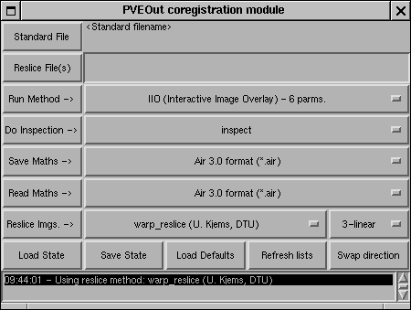
Upper layer of the interface looks like:
Figure 1: Illustration of the upper layer in the user interface for image registration

This interface is used for:

- Selection of Standard File / Reslice File(s), what image(s) should be registered to which image?
- Selection of the registration method to use.
- Selection of 'inspection' module. Visually inspecting registration output is important for catching possible registration problems.
- Reading/Saving coregistration mathematics (up to 12 parameter affine)
- Reslicing of the image(s).

Example of graphical user interfaces:
In other part of the program there is a need for graphical user interfaces for selection of points, moving the images with the mouse, feedback to users, and eventually inspections of the result of a co-registration. The following figures illustrates what it is possible to implement within the Matlab toolbox:
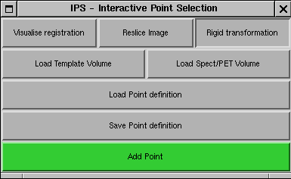
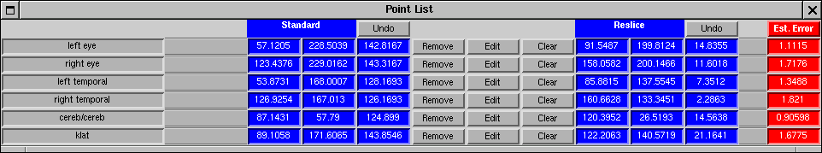
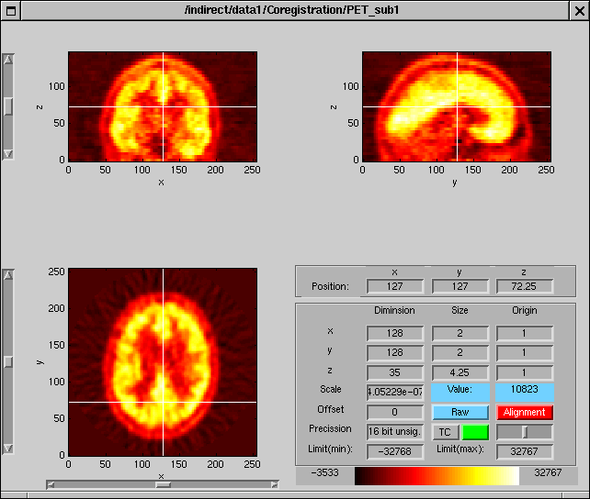
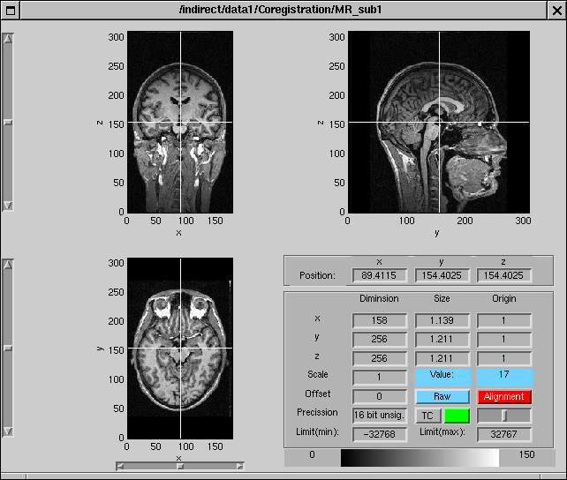
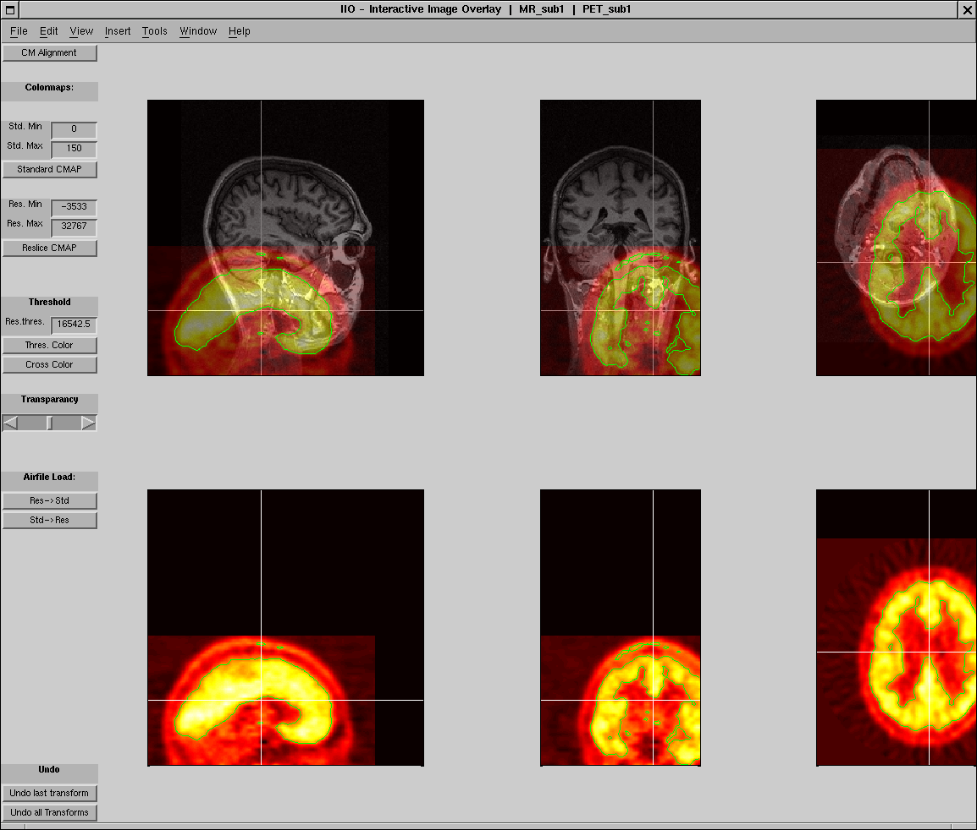
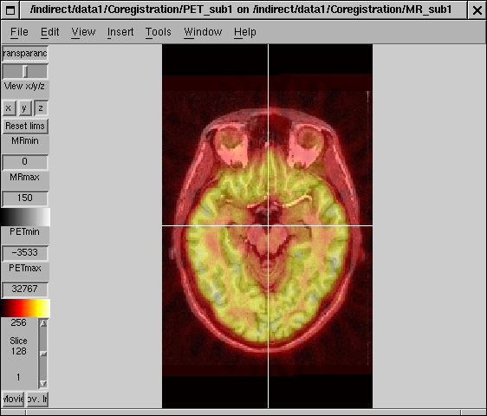
Figure 1: Program for coregistration images based on selection of points. Upper pane shows program control, middle two panes shows point selection windows, lower pane shows feed-back to users on precision achieved.
Figure 1: Program for co-registration of images based on overlaying images and moving them with the mouse or arrow keys.
Figure 1: Program for inspecting alignment result using image overlay.
The programs behind these user interfaces are all written in Matlab but it is also possible to build interfaces to other programs as C or Fortran programs. In the example below a user interface to the program AIR 5 (Automatic Image Registration, Roger Woods, UCLA) a C program that can downloaded from the Internet is shown. This program is called as a shell program within the Matlab environment.

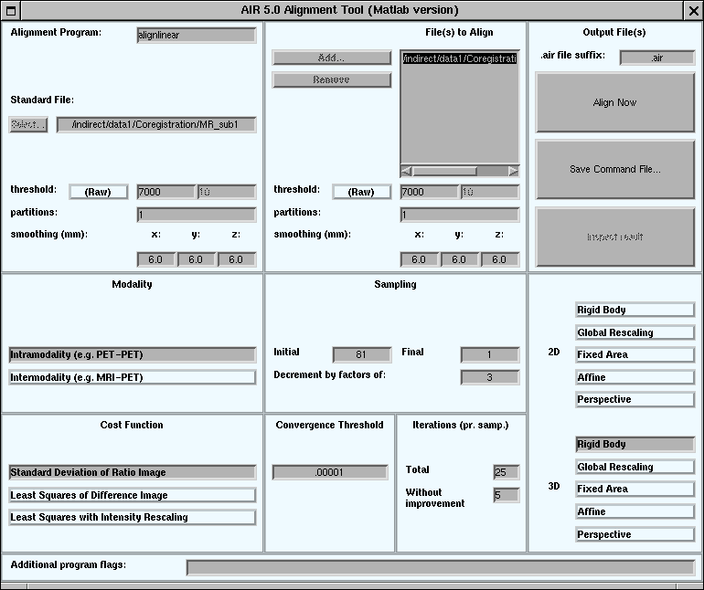
Figure 1: Userinterface to external program – the Automatic Image Registration software, Roger Woods, UCLA

Possibilities for implementing a common GUI for the PVEOut package
Within the same framework that is already up and running for the co-registration part of the PVEOut project it is possible to implement a GUI for the total PVEOut software package. A possibility would be to have a GUI layer at the top where it is possible to call the individual software modules:

- Segmentation
- Co-registration
- ROI/Atlas software
- PVE correction algorithms

The modules will have to exchange data but individual GUI’s. A standard data format as the Analyze Image format could be used for data exchange, while all the implemented software modules are able to read and save data in this format.

What should be implemented for each module

Segmentation module
This is a C-program with a simple text based user interface. It is simple to implement a GUI in Matlab that can call this software module using the UNIX shell technique. It will also be quite simple to implement a visualization tool for controlling the output from the program, while the visualization tools already developed for testing results from the co-registration module can be used for this purpose.

Co-registration
A Matlab GUI is already implemented for this module.

ROI/Atlas software
The Atlas functions implemented in Naples already have a GUI based user interface. So from Matlab it is only needed to implement a simple interface that can start the programs with the correct techniques and perhaps files selected.

PVE correction algorithms
The PVE correction algorithm is implemented as C programs and can from within Matlab be called as shell programs. How the procedures are called has to be negotiated so a GUI for entering data and controlling results can be build within the Matlab framework
Attachment III
EXPLOITATION DOCUMENTS
(Previously forwarded sent to the Mid-Term Reviewer Dr. F. Kruggel)
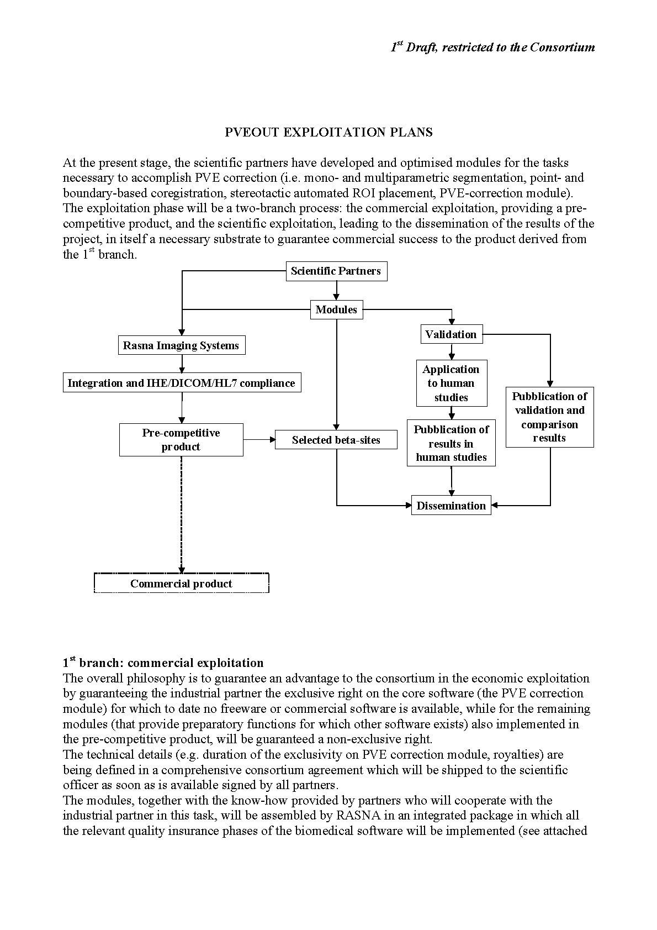
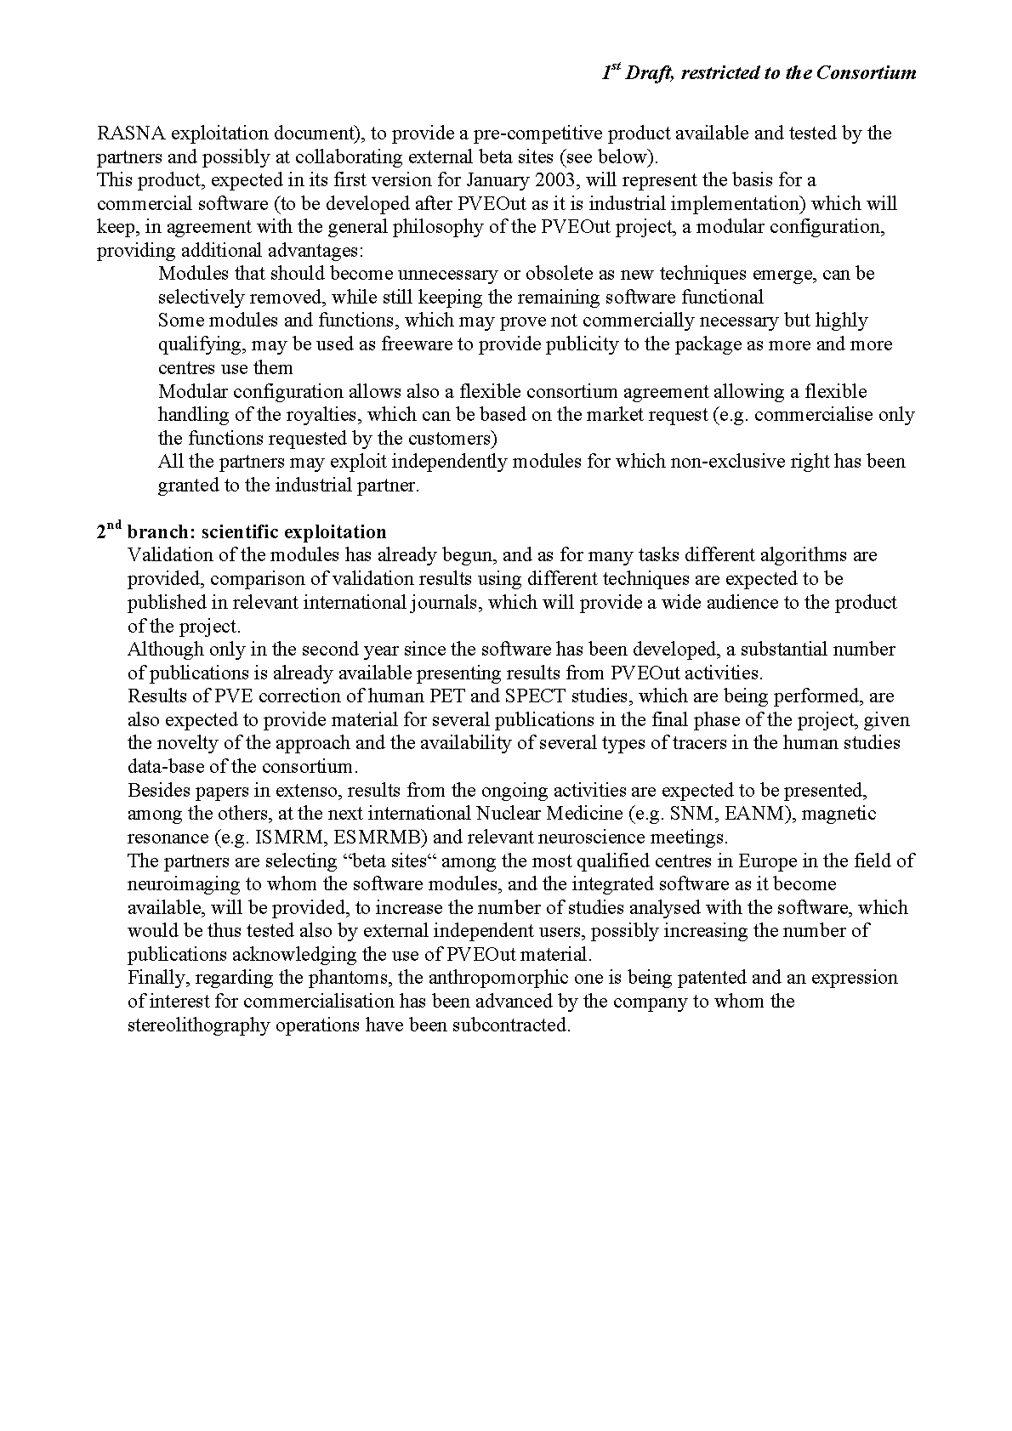
RASNA EXPLOITATION DOCUMENT
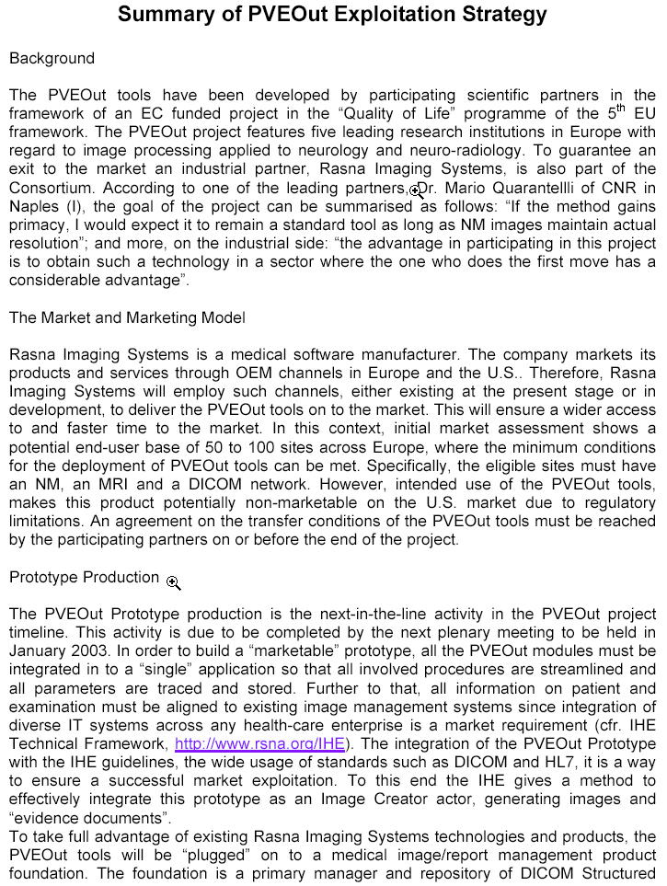
Page 1
