PVEOut project
4th Plenary Meeting

Internal Report

(Stockholm, 13 June 2002)

Participants to the meeting:
Alan Colchester (UKENT - Great Britain)
Ali Hojjat (UKENT - Great Britain)
Balázs Gulyás (KI – Sweden)
Bruno Alfano (CNR – Italy)
Claus Svarer (RHC – Denmark)
Jean-Claude Baron (Inserm – France)
Johan Lundberg (KI – Sweden)
Judith Sovago (KI – Sweden)
Karim Berkouk (Inserm – France)
Lapo Bertini (RASNA – Italy)
Laszlo Balkay (DPC – Hungary)
Mario Quarantelli (CNR – Italy)
Olaf B. Paulson (RHC – Denmark)
Per Karlsson (KI – Sweden)
Peter Willendrup (RHC – Denmark)
Simon Cervenka (KI – Sweden)

Introduction and background to the project.

Partial volume effect and how it can be corrected
Overview on the progress of the project (CNR)
WP2 Software architecture (UKENT)
- "MARS: Multiple Algorithms for Registration of Scans" (Peter Willendrup - RHC)
- Segmentation, monoparametric (UKENT)
- Segmentation, multiparametric (CNR)
- ROI set-up (CNR)
- PVE correction (CNR - INSERM.PPSN)
WP3 Phantom production (CNR)
WP4 Validation on virtual phantom (UDEB.PETC)
PVE in neuroreceptor studies (KI.DCN)
Issues for industrial implementation (RASNA) and Prospects of the project (CNR)

Introduction and background to the project

Partial volume effect and how they can be corrected

Overview on the progress of the project (CNR)
Aim of this introduction was to define the current status of the project, and to summarize the open issues to be addressed for the subseqeunt steps.
Dr. Alfano pointed out that the scientific results so far achieved were absolutely remarkable, and that there was a delay in two aspects of the project: physiscal phantom production and integration of the different software modules.
Regarding phantom production, the delay was due to a change in the strategy of phantom development, as defined at the Naples Plenary Meeting, which had been re-defined to allow, at no extra cost for the project, the production of different subsequent versions of the phantom at increasing degrees of complexity (see below the "Phantom production" section).
Regardin the integration of software modules, which was linked to the different set-up of the industrial and scientific partners, it was decided to have in Florence.the optional operative meeting originally anticipated for this purpose in the original workplan.

WP2 Software architecture (UKENT)
Software architecture is almost complete in terms of design, while the GUI and main program are still to be defined (see above and the "prospects of the project" section).
The use of the various packages on several PET/MRI studies demonstrated that the modules were correctly communicating.
Preliminary testing of PVE-correction has been done, among the others, on Iomazenil, ECD and HMPAO SPECT scans from AD patients and FDG/PET studies in AD patients and Normal Volunteers.

"MARS: Multiple Algorithms for Registration of Scans"
(Peter Willendrup - RHC)
Under Peter Willendrup guidance, partners discussed various aspects of the MARS software and shared their experiences with the software. Availability at the meeting of MARS installed on some of the portable PCs allowed the participants to practically verify the use of the software on actual FDG and IOMAZENIL data sets to povide a feed-back to the author of the software (PW).

Segmentation, monoparametric (UKENT)
Ali Hojatt presented the results of the segmentation of some MRI studies received by some of the partners, along with a preliminary comparison with other segmentation tools.
There was a general consensus on the quality of the segmentation as compared to other segmentation techniques (mainly SPM) which the other partners had experience with.

Segmentation, multiparametric (CNR)
The multiparametric segmentation module had been placed on the PVEOut FTP site, and examples of the application of the software in Multiple Sclerosis and Cerebrovascular disease were presented.
It was stressed that this segmentation represented a trade-off between spatial resolution and the ability to distinguish pathoilogica tissues, a feature useful for PVE correction in pathologies where these tissues may represent a substantial quote of intracranial tissues.
Progression in automatization of segmentation of Fast-Spin-Echo Images, which may lead this module to reach a resolution comparable to T1w volumes were reported.

ROI set-up

Mario Quarantelli
Biostructure and Bioimaging Institute
National Council for Research
Naples - Italy
The ROI module had been completely written in IDL at the time of previous plenary meeting and its implementation in C is now completed and debugged, and it has been made available along with the PVE correction module as a single package on the project website for downloading.
Validation of the ROI module versus manual tracing of large cortical GM ROIs and main ventricular structures has been accepted for publication on NeuroImage and will appear in the September issue.
The format of the output of the ROI module and consequently the format of the corresponding input required by the PVE correction module, have been kept as simple as possible (a bitmap where each GM voxel is labelled with the number corresponding to its structure, with a ascii file reporting the couples Label - ROI).
This allows, as originally defined in the project set-up, to import easily output from other digital atlases, provided they are able to label the GM voxels in the PET space.
Most software however, as emerged in the survey (see table), deform the patient study to match the atlas, a strategy not directly suitable for subsequent PVE correction, which is carried out in the PET space, where a description of the resolution features is available.
For one of the most widely diffused “spatial normalization” tools, the SPM normalization routine which deforms the patient PET or MRI study to match the MNI atlas space, which is considered extremely robust, is being considered the possibility to write a procedure to revert the transformation matrix to deform the MNI space, along with its set of structure labels, onto the PET study, thus providing labelling of GM voxels in the PET space.
This task will be started by jointly by Karim Berkouk and Mario Quarantelli, initially modifying the IDL program, and then eventually implementing the same modification s in then C program as an option, to allow interested researchers to use this normalization tools which has the advantage of being fully automated.

Partial Volume Effect Correction Implementation in PVEOut
Karim Berkouk  INSERM U.320 CYCERON  Caen - France | Mario Quarantelli  Biostructure and Bioimaging Institute  National Council for Research  Naples - Italy

The four PVE correction techniques implemented in PVEOut were summarized and a discussion of some specific aspects of their final implementation in the software followed.
The four techniques are:
- Correction of each PET voxel value taking into account only loss of GM activity due to spill-out toward extra-parenchymal tissues (CSF and extra-cerebral structures), assumed to have a negligible activity [Meltzer C.C., 1990]. This method is hereinafter referred to as “M-PVEC”

Meltzer CC, et al. Correction of PET data for partial volume effects in human cerebral cortex by MR imaging. J Comput Assist Tomogr 1990 Jul-Aug;14(4):561-70
- Correction of each PET voxel value taking into account the loss of GM activity due to spill-out toward non-GM tissues (CSF, WM and extra-cerebral structures), as well as the relatively small spill-in from adjacent WM [Müller-Gärtner H.W., 1992]. This method assumes the “true” WM mean value to be measurable in a large WM region potentially void of PVE, selected for the current implementation in the center of the centrum semiovale slice. This method is hereinafter referred to as “MG-PVEC”.

Muller-Gartner HW, et al. Measurement of radiotracer concentration in brain gray matter using positron emission tomography: MRI-based correction for partial volume effects. J Cereb Blood Flow Metab 1992 Jul;12(4):571-83

Correction of ROI values achieved taking into account the spill-in and spill-out between each possible couple of ROIs, thus constructing a transfer matrix which constitutes with the corresponding PET values a system of equations whose solution provides “true” ROI values [Rousset O.G., 1998a]. This method is hereinafter referred to as “R-PVEC”

Rousset OG, et al. Correction for partial volume effects in PET: principle and validation. J Nucl Med 1998 May;39(5):904-11

Finally, as MG-PVEC relies on the knowledge of “true” WM concentration, which may be more or less accurate depending on the setting of the measure, it was proposed [Rousset, O.G., 1998b] that it may take advantage of using the WM value calculated according to R-PVEC. We have implemented this modification to MG-PVEC and will refer to it as mMG-PVEC

Rousset OG, Ma Y, Wong DF, Evans AC. Pixel- versus Region-based Partial Volume Correction in PET. In Quantitative Functional Brain Imaging with Positron Emission Tomography. 1998

M-PVEC

First, the map of brain parenchyma (i.e. a coregistered segmented MRI in which GM and WM voxels have been set to 1, and to 0 otherwise) is convoluted by the in-plane PSF of the corresponding PET by gaussian-filtering its Fast Fourier Transform (FFT). This provides a map of the spill-over aspect of PVE, each voxel having a value ranging from 0 to 1, 1 meaning that 100% of the activity contained in that voxel comes from the brain, while lower values indicate that a progressively decreasing fraction of the activity measured in that voxel derives from the brain. The map is then smoothed along the Z-axis to consider also axial resolution, providing a correction map for the PET.

PET parenchyma voxels (i.e. voxels labeled as GM or WM in the segmented registered MRI) are then divided by the corresponding value in the correction map, while other pixels are zeroed.

MG-PVE

To take into account the different properties of GM and WM, determining a spill-out effect from GM into WM and a spill-in effect from WM into GM, WM activity can be first subtracted by the PET, thus leaving the residual activity only due to GM. This can be done, under the assumption of homogeneity of WM tracer concentration (reasonable for most PET/SPECT studies) provided the mean WM concentration can be accurately measured in a region where PVE is low.

The operator is thus interactively allowed to select a slice where a large WM region is present (in our case, for the validation procedure described below, the same slice containing the centrum semiovale was always selected). The software then derives the mean values of the voxels labeled as WM in the corresponding segmented MR image, after a 6-pixel erosion of the edge of the ROI to avoid the peripheral WM which presents larger PVE from surrounding GM.
A WM virtual PET is then generated by convoluting the WM map (i.e. the WM voxels in the segmented images set to the measured mean WM value), by the in-plane PSF and then smoothing it along the Z-axis to replicate the PET axial resolution. The resulting set of images represents in essence the counts in the PET due to the WM.
The WM virtual PET is therefore subtracted by the observed PET, leaving only the counts due to the GM structures.
The images obtained are then corrected similarly to M-PVEC, dividing only GM voxels by the corresponding values from a GM correction map (i.e. a correction map obtained by in-plane Fourier filtering and axial smoothing of GM map), while non-GM voxels are zeroed.

R-PVEC

The following steps are performed to obtain PVE-corrected ROI values:

the ROI set (including WM) is applied to the PET study to derive original PET values.
- each ROI is 3D-smoothed as in the two previous algorithms (in-plane FFT filtering and axial smoothing) replicating the PET resolution.
- the ROIs of structures supposed to concentrate the tracer (in our case the GM ROIs) are dilated in 3D using a 2x2x2 kernel, while the low-activity ROIs (here the WM ROI) are 3D-eroded accordingly. This is done to minimize the effect of misregistration onto the accuracy of the following calculations. To clarify this point a simple 2D example was discussed, in which the effects of errors in FWHM, segmentation and registration onto a frontal ROI were simulated, showing that this approach minimized the relative error in estimating ROI values, and thus the resulting errors in the corrected values.
Using a frontal ROI, 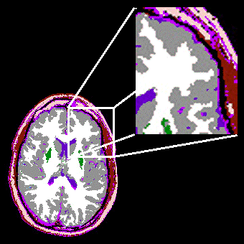 FWHM and coregistration errors will result for example in errors in the estimate of the concentration in that structure on the PET (e.g. here a 4 pixel registration error results in –23% underestimation of GM and +19% overestimation in WM).
These errors cannot be simply fixed when using pixel-based methods (i.e. M-PVEc, MG-PVEc and mMG-PVEc), and furthermore they propagate in the PVE correction processes.
Since R-PVEc does not necessarily derive the corrected value of each ROI from its uncorrected value but derives essentially the whole set of corrected results from a set of equally numerous ROIs, there is no need to restrict each ROI to the structure of interest, but they can be extended in the surrounding “cold” tissues (e.g. WM).
In the same example, the resulting error on the GM ROI is decreased for misregistration, and dramatically decreased for FWHM errors.
Analogously, “cold” tissue ROIs can be restricted to their core, avoiding periphery where larger errors results, for example, from residual misregistration.
This philosophy has been thus applied to the ROI application for the R-PVEc in the corresponding software module.
- For each ROI, the percentage of the activity spilling into each dilated (or eroded, for WM) ROI is measured, and is stored as member of a transfer matrix.
- The transfer matrix members with a value lower than a fixed threshold (here arbitrarily set to 1%) are zeroed. This reduces the noise amplification inherent to the subsequent calculation by eliminating the effect onto the calculation of the influence between distant structures. The original PET values and the transfer matrix constitute a system of linear equations with the same number of equations and unknowns, the unknowns being the true mean ROI values
- The transfer matrix is inverted by Single Value Decomposition to solve the system of equations allowing the calculation of the unknowns which represent our best estimates of the true mean value of each ROI.

mMG-PVEC
Since MG-PVEC requires a-priori knowledge of the true WM value, derived by a measure which in turn is somewhat still influenced by PVE (e.g. even for a large structure like centrum semiovale there is still PVE from surrounding GM matter and underlying ventricular CSF), it has been proposed to use the theoretically more accurate estimate provided by the R-PVEC for WM mean value to increase the accuracy of the technique.
The software performs also this task replicating the MG-PVEC process using as WM value the one provided by the R-PVEC module.

Since the result of M-PVEC, MG-PVEC and mMG-PVEC are PVE-corrected images, the ROI set provided by the ROI module and used in the R-PVEC procedure is also applied to the uncorrected PET and to the three sets of corrected PET images to derive corresponding uncorrected and corrected data, which are saved in a text file suitable for loading into any spreadsheet.

Operatively, the software follows the following steps:
- Input filenames of PET of corresponding segmented labelled MRI co-registered to PET (rebinning of PET prior to reslicing of MRI advised). SPM filename convention is assumed (FILENAME_seg1.img for GM…, rFILENAME.img for registered images...)
- Traces the corresponding GMROI file (WM is assumed always to be homogeneous throughout the brain
- Asks for WM slice (i.e. the slice from which WM activity is measured, centrum semiovale advised)
- Dilates GM (or “hot”) ROI’s by a fixed amount of pixels (avoiding other relevant structures)

- Looks in patients directory for a file describing the Low-pass filter to use for virtual PET generation, otherwise uses the prescribed Axial and In-Plane FWHMs
- Generates WM PET for subtraction in MG and for TM calculation in Rousset
- Generates a virtual PET for each GM ROI and calculates Trasfer Coefficients between each ROI virtual PET and dilated ROI’s
- Zeroes the TM values below a pre-defined threshold (to decrease noise propagation in Rousset approach)
- Calculates PET values for original ROI’s

- Cuts a prescribed % topmost part of the Meltzer and Mueller-Gartner histogram (this is done to allow a clear display of the corrected images obtained by M-PVEc, MG-PVEc and mMG-PVEc, which may have extremely “hot” spikes due to segmentation and registration errors, and does not affect actual quantitative results reported in the output file)
- Generates and save in Analyze and DICOM format the corrected PET according to Meltzer, Mueller-Gartner and Mueller-Gartner modified
- Applies original ROIs to PET, and corrected images to get corresponding values
- Outpout to ASCII file further analysis
For DICOM output, in the absence of a DICOM standard for PVE-corrected images, the format of the original images is used also for saving, assigning a secondary/derived tag to the images, which clarifies that these are processed images.
Phantom production (CNR)

At the last meeting in Naples still unsolved problems were the following:

Walls are thicker than predicted

Presence of internal thin supports

There is a comunication between the two chambers
Wall thickness had been reduced to .5mm on average, and GM and WM chambers are now correctly separated. Furthermore, adequate emptying of then ventricles from the liquid resin is now guaranteed by creating wide channel between third ventricle and inner surface of the brain.
Internal supports have also been minimized and do not pose a significant problem for the use of the phantom as they do not impede the filling of the chambers and cannot be seen at preliminary test SPECT images.

A preliminary SPECT study of the anthropomorphic phantom has been presented.
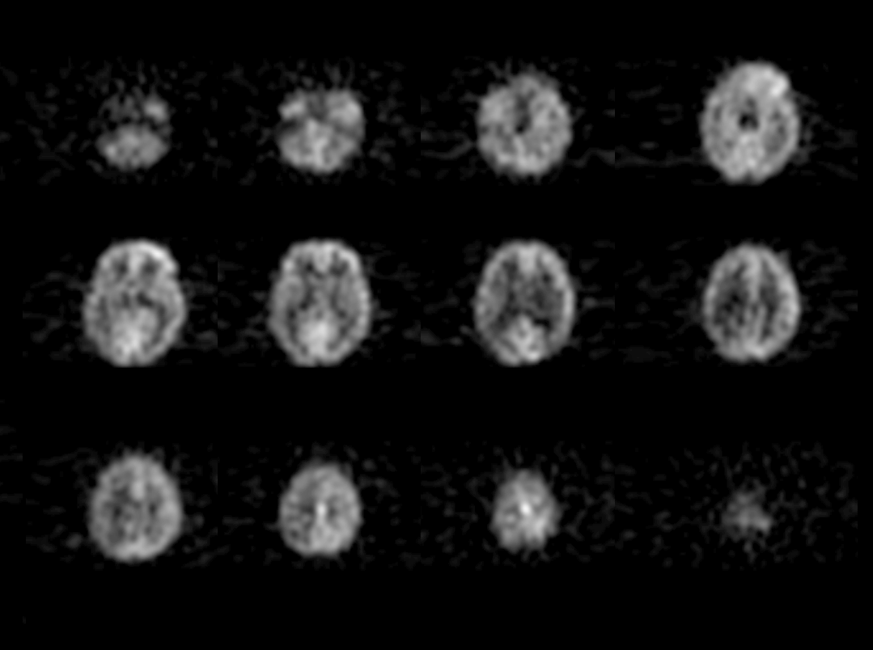
SPECT axial sections from a 2-Head gammacamera

Also, actual sections of an anthropomorphic phantoms have been brought at the meeting to display the inner structure.
Circulation of the phantom among the partners will begin after a few initial studies have been made in Naples to define the procedures for phantom filling and emptying with the appropriate solutions for different PET, SPECT and MRI (both T1w volumes for monoparametric segmentation and T1w/DPw/T2w sequences for multiparametric segmentation).
While the first phantom circulates, a second phantom will be produced with improved GM complexity (reduced smoothing before GM/WM interface definition), and possibly with a separate compartment for basal ganglia, to simulate neuroreceptor studies.
This strategy, although delaying the WP3 progression as compared to original workplan, will allow to maximize its results both in terms of quality and flexibility of the final prototypes, without imposing any additional costs to the project.
The geometric phantom, which is also ready, will be shipped along with the anthropomorphic phantom to allow for scanning of the two objects in the same sessions.
Validation (CNR / INSERM.PPSN)
Validation on virtual phantom (UDEB.PETC)
Dr. Balkay presented the current status of PET simulator, and preliminary results from its application as compared to actual PET scans were presented. A request was made to Dr. Balkay to verify the possibility to simulate also the SPECT process.
A discussion on how virtual phantom data should be used in validation was held, which resulted in the draft reported hereinafter.
The implemented PVE correction methods are based on the exact knowledge of the composition of each PET voxel, supposedly provided by a perfectly registered segmented MRI, and of the knowledge of the resolution of the PET images along the three axis.
While this is true for our test object (the virtual PET is intrinsecally registered with the MRI from which it was generated, the segmentation of the MRI has been the basis of the PET simulation process, simulated PET resolution could be calculated pixel by pixel), this is not the case for real PET studies.
The main reasons for this are errors associated with the registration procedures, the resolution of emission tomography images is not constant across the field of view degradating from the center to the periphery of the field of view up to 40% for brain-dedicated scanners [Hoffman EJ, 1982], and finally there are no data on the actual accuracy of MR segmentation techniques applied to human brain studies, as there is no gold standard for such a measurement.
To assess the performance of the PVE correction procedures under a large range of conditions expected in actual data from human brain studies in research and clinical practice, will be tested introducing the following errors:
- different degrees of registration error ranging from 0 to 6 pixels. This was obtained by increasingly shifting the segmented MRI along the X axis with respect to the virtual PET (Figure error C)
- different degrees of segmentation error ranging from -10% to +10% of GM volume estimation error (in favor or at the expenses) of the WM compartment, simulating a systematic shift of the GM/WM interface alternately into one of the two tissues).
- different degrees of resolution mismatch, to cover the error range due to the fact that the FWHM etherogeneity is not simulated.
The simulated error ranges will be selected to simulate the errors actually encountered on true data analysis, as derived from the reviews delivered from WP1.
Consequently, for each ROI and for each technique a large number of combination of errors will be obtained which will serve has basis for the assessment of the accuracy of PVE correction using the four methods.
Subsequent data analysis will be carried out on the three corresponding subsets of data, each one characterized by a single source of error (e.g. the subset with segmentation error is formed by the results obtained in the fourteen simulations without misregistration or resolution estimate error), in order to allow the assessment of the sensitivity of each PVE correction method to the three errors separately, and on the whole data set comprising all combinations of errors (to provide estimates of the overall accuracy of each correction method).

In evaluating the accuracy and precision of the uncorrected measures as well as of the four PVE correction methods, the following three figures of merit will be used:
Accuracy will be estimated by GM and WM recovery (hereinafter GMR and WMR, analogous to GMR used by Meltzer et al. [Meltzer C.C., 1990]), defined for each ROI as the ratio between the measured value and the correct value. For these two figures 100% represents the perfect correspondance between the value used in simulation (i.e. 255 for GM and 64 for WM) and the measured value either before or after correction, while <100% indicates underestimation, and >100% overestimation.
Precision will be measured by the Coefficient of Variation of the 15 GM ROI values (hereinafter GM-CV). The GM-CV will be calculated for each single set-up (i.e. for each combination of errors) as the CV of the 15 GM ROIs. GM-CV equal to 0% indicates an internal perfect consistency of the results.

PVE in neuroreceptor studies (KI.DCN)
Dr. Gulyás introduced the researcher in KI group who are working on PVE correction in neuroreceptor studies.
The range of neuroreceptor PET studies available at KI was discussed, and it was emphasized the necessity to be able to run in batch mode the PVE correction to analyze appropriately dynamic studies.

Issues for industrial implementation (RASNA) and Prospects of the project (CNR)

A discussion on subsequent steps of the project, including exploitation phase, to allow both scientific and commercial issues to be satisfied, was carried out among the scientific partners, and continued, stimulated by the Expert Reviewer questions during the Mid-Term Review, in a round of emails.
The scientific partners have developed and optimised modules for the tasks necessary to accomplish PVE correction (i.e. mono- and multiparametric segmentation, point- and boundary-based coregistration, stereotactic automated ROI placement, PVE-correction module).

The exploitation phase will be a two-branched process: the commercial exploitation, providing a pre-competitive product, and the scientific exploitation, leading to the dissemination of the results of the project, in itself a necessary substrate to guarantee commercial success to the product derived from the 1st branch.

1st branch: commercial exploitation
The modules, together with the know-how provided by partners, who will cooperate with the industrial partner in this task, will be assembled by RASNA in an integrated package in which all the relevant quality insurance phases of the biomedical software will be implemented (see RASNA exploitation document), to provide a pre-competitive product available and tested by the partners and possibly at collaborating external beta sites (see below).
This product, expected in its first version for January, will represent the basis for a commercial product (to be developed after PVEOut, being industrial implementation) which will keep, in agreement with the general philosophy of the PVEOut project, a modular configuration, providing two additional advantages:
- It allows a flexible consortium agreement allowing a flexible handling of the royalties, which can be based on the request (selling only the requested modules, and paying only the corresponding royalties)
- All the partners may exploit commercially or scientifically (i.e. distribuite to other centres for scientific reasons) only selected modules, without being forced to deliver the whole software
- Modules that should result not needed or obsolete as new techniques emerge, can be selectively dismissed, yet keeping the remaining software working
- Some modules and functions, which may prove not commercially necessary but highly qualifying, may be used as freeware to provide publicity to the package as more and more centres use them
2nd branch: scientific exploitation
Validation of the modules has already begun, and as the for many tasks different algorithms are provided, comparison of validation results using different techniques are expected to be published on relevant international journals, which will provide a wide audience to the product of the project.
Results of PVE correction of human PET and SPECT studies, which are being performed, are also expected to provide material for several publications in the final phase of the project, given the novelty of the approach and the availability of several types of tracers in the human studies data-base of the consortium.
The partners are selecting “beta sites“ among the most qualified centres in Europe in the field of neuroimaging to whom the software modules, and as it become available the integrated software, will be provided, to increase the number of studies analysed with the software, which would be thus tested also by external independent users, possibly increasing the number of publications acknowledging the use of PVEOut material.

In summary, the overall philosophy is to guarantee an advantage to the consortium in the economic exploitation by guaranteeing the industrial partner the exclusive right on the core software (the PVE correction module) for which to date no freeware or commercial software is available, while for the remaining modules, which are being also implemented in the pre-competitive product (which provide preparatory functions for which other software exists), will be guaranteed a non-exclusive right.
The technical details (e.g. duration of the exclusivity on PVE correction module, royalties) are being defined in a comprehensive consortium agreement which will be shipped to the scientific officer as soon as is available signed by all partners.

